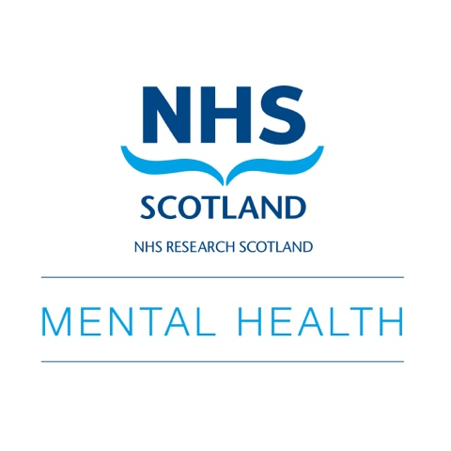

NHS Research Scotland Mental Health
Travelling Fellowship Fund
2024

What is this funding for?

To support researchers of all disciplines working within mental health to attend conferences (i.e. travelling expenses and / or registration fees) for career development. Awards of £250 for UK conferences and £500 for international conferences are available. We expect to fund 8 UK and 4 international Fellowships a year.

Applicants should be able to state clearly how the Fellowship will support their career development. Applicants will be expected to briefly report back issues of interest to the NRS Mental Health Network.

Who can apply?

- Members of the Network Teams channel (you may join and immediately apply)
- Members who are engaged in or can demonstrate commitment to conducting clinical research.
- Who do not have major (e.g. fellowship) external research funding.

We encourage applications from diverse applicants, especially from underrepresented groups and/or those working with underrepresented groups.

How will applications be evaluated?

Your application will be considered by the Network management team, who will consider whether the application meets the funding criteria.

Terms and conditions

Outcomes will be communicated directly with applicant. Successful applications will be publicised by the Network on the Teams channel, social media, and the Network Website.

- We can book and pay for travel arrangements.
- We can pay conference registration fees in advance or in retrospect.
  - Successful applicants must briefly report back on their experience to the Network which will be publicised.

Application procedure

Please complete attached application form and return by email to Catherine.Deith@ed.ac.uk.

Application Form

Section 1: Applicant information

Name

Role

Email address

Organisation

Please confirm your eligibility for this scheme by stating how you meet the criteria (please see ‘who can apply’ section of the funding information sheet)
Section 2: Event information

Name of Event/ Conference

Date of Event/ conference

Venue
In 300 words or less, please outline how attending this event this will help your career development.

Section 3: Declaration

Funding request (£250 or £500)

Do you agree to write a short report (300 words) for the Network on the event/ experience?
Do you agree to your success being publicised by the NRS Mental Health Network?
Signed | Date

